**DAILY ONLINE ACTIVITIES SUMMARY**

|  |  |  |  |  |  |  |  |  |
| --- | --- | --- | --- | --- | --- | --- | --- | --- |
| **Date:** | **18/05/2019** | | | | | **Name:** | **Shone k Sunny** | |
| **Sem & Sec** | **8th A** | | | | | **USN:** | **4AL14CS081** | |
| **Online Test Summary** | | | | | | | | |
| **Subject** | | **SMS** | | | | | | |
| **Max. Marks** | | **60** | | **Score** | | | **15** | |
| **Certification Course Summary** | | | | | | | | |
| **Course** | **Getting Started To Hadoop** | | | | | | | |
| **Certificate Provider** | | | **GreatLearning** | | **Duration** | | | **14 mins** |
| **Coding Challenges** | | | | | | | | |
| **Problem Statement:** | | | | | | | | |
| **Status: Completed** | | | | | | | | |
| **Uploaded the report in Github** | | | | | **yes** | | | |
| **If yes Repository name** | | | | | **shonekks** | | | |
| **Uploaded the report in slack** | | | | | **yes** | | | |

Online Test Details: (Attach the snapshot and briefly write the report for the same)

Online Test Details:

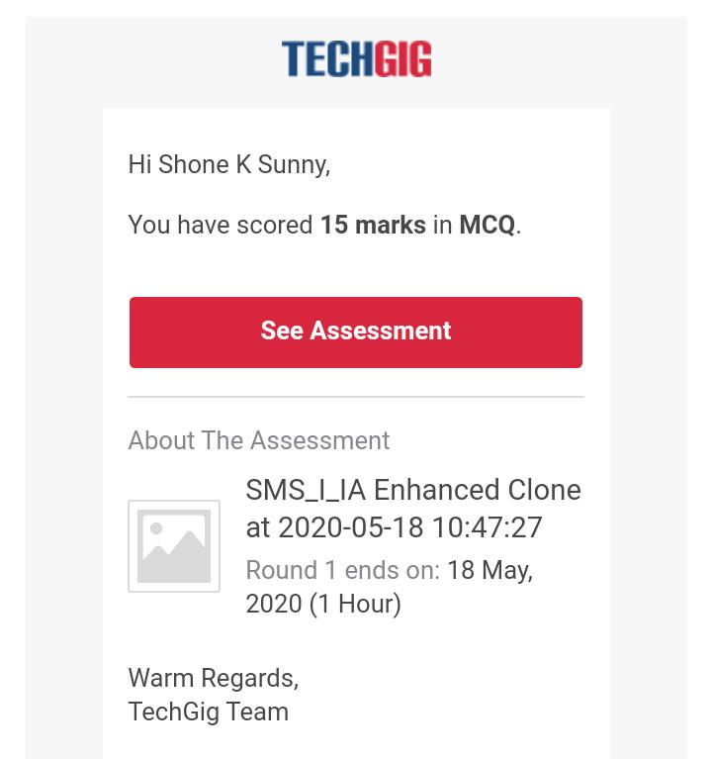

Certification Course Details:

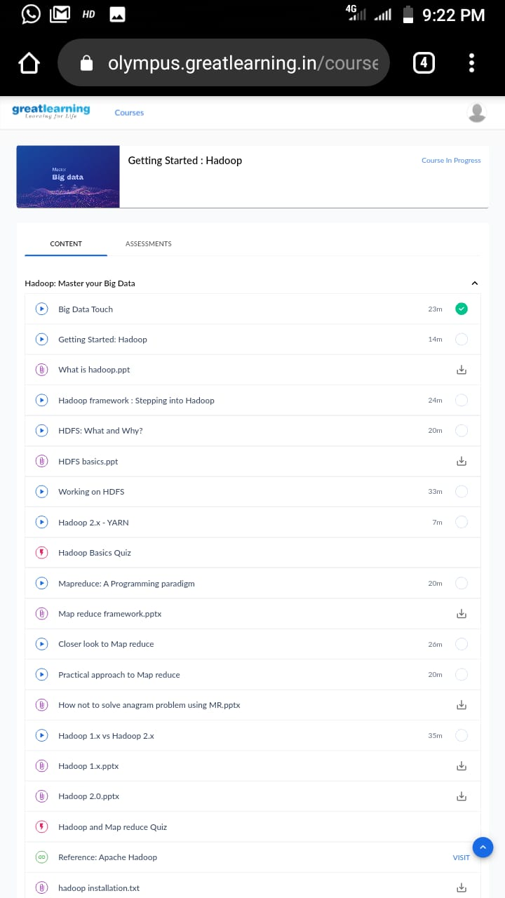

Coding Challenges Details:

**Program 1:**  
import java.util.Scanner;  
public class Main  
{  
public static void main(String[] args) {  
int i;  
String str;

int count[] = new int[256];

Scanner s = new Scanner(System.in);

System.out.print("Enter a String : ");

str=s.nextLine();

for (i = 0; i < str.length(); i++) {

count[(int) str.charAt(i)]++;  
}

for (i = 0; i < 256; i++) {

if (count[i] != 0) {

System.out.println( (char) i + " : " + count[i]);

}  
}  
}  
}

**program 2:**

public class PingPong extends Thread {  
static StringBuilder object = new StringBuilder("");  
public static void main(String[] args) throws InterruptedException {

Thread t1 = new PingPong();  
Thread t2 = new PingPong();

t1.setName("\nping");  
t2.setName(" pong");

t1.start();  
t2.start();  
}

[@override](https://github.com/override)  
public void run() {  
working();  
}

void working() {  
while (true) {  
synchronized (object) {  
try {  
System.out.print(Thread.currentThread().getName());  
object.notify();  
object.wait();  
} catch (InterruptedException e) {  
e.printStackTrace();  
}  
}  
}  
}  
}